The RELATED function is used to fetch a value from a related table, following a relationship between two tables in a data model.

There is may to one relationship between Sales[ProductID] and dim_product[ProductID]

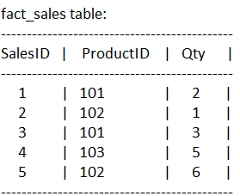 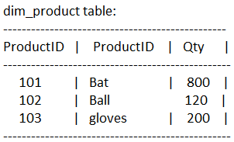

In fact_sales table, Create a new column as:

ProductName = RELATED(dim_product[ProductName])

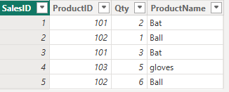

In fact_sales table, Create a new column as:

Total Amt = fact_sales[Qty] * RELATED(dim_product[Price])

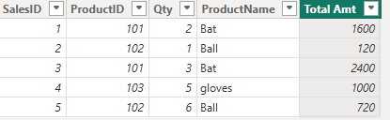

When you want to do calculate total sales per product dim_product table.

In dim_product table, Create a new column as:

Product Sales value = SUMX(RELATEDTABLE(fact_sales),fact_sales[Total Amt])

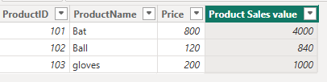

When you want to calculate total qty per product are sold in dim_product table.

In dim_product table, Create a new column as:

TotalQuantity = SUMX(RELATEDTABLE(fact_sales), fact_sales[Qty])

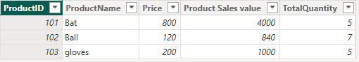

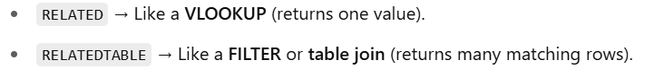

* **RELATED** – fact table <- dim table (many to one),

Bring a column value from a related parent

* **RELATED TABLE** – dim table <- fact table (one to many),

Fetch related child rows for aggregation/filtering